Applying the equation of a linear relationship
in biology
Specification references
- 3.1.4, 3.2.3, 3.5.1
- MS 3.3, MS 3.4, MS 3.5. MS 3.6
Learning outcomes
After completing this worksheet you should be able to:
- revise the equation for a linear relationship
- use the equation to find unknown quantities and predict the shapes of graphs.
Introduction
This task is designed to allow you to practise with the equation of a line on a graph. When there is a straight line on a graph the position of the line can be described using the equation y = mx + c. In this equation c is the intercept of the line on the
y-axis and m is the gradient of the line. The equation may be used to find points on a line or to predict the position of a line from given data.
You should already be familiar with the equation of a line from your GCSE studies.
An example of an A level topic you have studied which should yield a straight line relationship is the reaction rate rising as enzyme concentration rises. You will have studied this in Chapter 1.8 ‘Factors affecting enzyme action’. A line graph with an intercept is likely to be encountered when you plot data from osmosis experiments such as % change in mass of potato cylinders against the concentration of the bathing medium. You will have studied this in Chapter 4.3 ‘Osmosis’ of your Student book.
Worked example
Figure 1 shows an example of a graph.
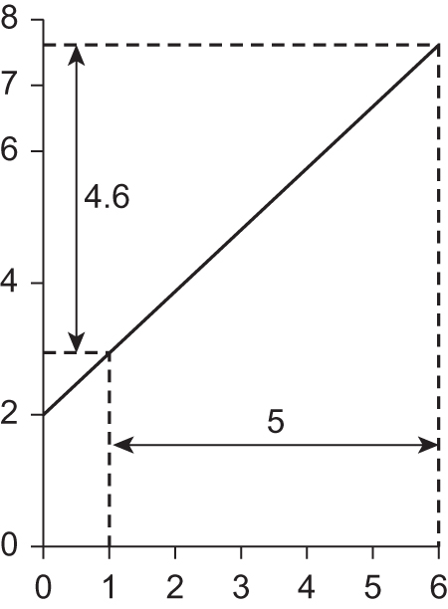
Figure 1
Question
a Calculate the gradient, m, of the line.
Answer
Step 1
Mark any two points along the line and use construction lines to find the distance between them along each axis. In this example, change in y is 4.6 units and in x 5 units.
Step 2
Divide the change in y by the change in x to find the gradient.
m = 4.6 ÷ 5 = 0.92

b Calculate the equation of the line.
Step 1
First find the intercept, c, on the y-axis. Here c = 2.
Step 2
Now substitute the values for the gradient and the intercept into the equation.
y = mx + c y = 0.92x + 2

c Calculate the value of y when x = 3.
Step 1
Replace x in the equation with the known figure to give
y = (0.92 × 3) + 2 So y = 4.76

d Sketch the graph that corresponds with the equation y = 4x + 6
Step 1
Choose any two values for x, say 2 and 5. These will be the x coordinates for two points along the line.
Step 2
Using the equation, find the corresponding y coordinates.
when x = 2, y will be (4 × 2) + 6 = 14
when x = 5, y will be (4 × 5) + 6 = 26
Remember you also know the intercept, c, which is 6 in this example.
The result will look like Figure 2.
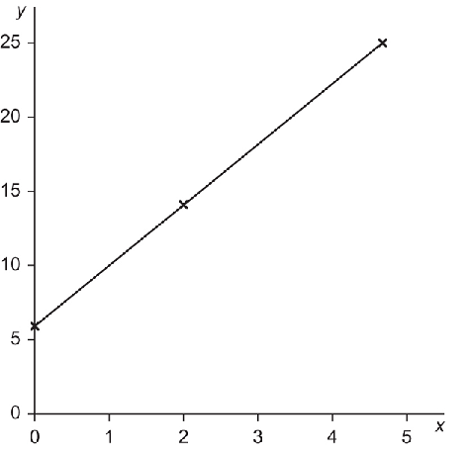
Figure 2
Questions
1 An experiment was conducted to find the rate of a reaction while varying the concentration of hydrogen peroxide (measured in mol dm⁻³) in the presence of excess catalase enzyme. The concentrations of hydrogen peroxide tested were 0.2, 0.4, 0.6, 0.8 and 1.0 mol dm⁻³. The rate of reaction was oxygen evolved by the reaction in mm³ s⁻¹
a The equation of the line was y = 87.5x + 0. Sketch the resulting graph.

(4 marks)
b What is the rate of oxygen production when the concentration of catalase is 0.5 mol dm⁻³?

(2 marks)

2 The percentage change in mass was found for samples of aubergine when soaked in solutions of salt (measured in %). The salt concentrations tested were 2, 4, 6, 8, 10, 12 and 14%. This gave a line graph with the equation y = −2.92x + 35.
a Sketch the resulting graph.

(3 marks)
b What concentration of salt has the same water potential as the aubergine cells?
(2 marks)
3 The photosynthetic compensation point occurs when the rate of photosynthesis is exactly balanced by the rate of respiration. In an experiment the oxygen production was measured in µmol m⁻² s⁻¹ and light intensity in lux. The resulting linear graph had the equation y = 0.001x − 5.
a At what light intensity was the compensation point?
(2 marks)
b What would be the net oxygen production at light intensity 10 000 lux?
(2 marks)
Maths skills links to other areas
Linear graphs appear in several areas of biology where one quantity varies uniformly with respect to another. Examples might include enzyme reactions, changing rates of transpiration, gas production during photosynthesis and oxygen consumption in respiration.

