**Week Beginning 7th October 2024**

**LAST WEEK’S ATTENDANCE**

**(30th September – 4th October 2024)**

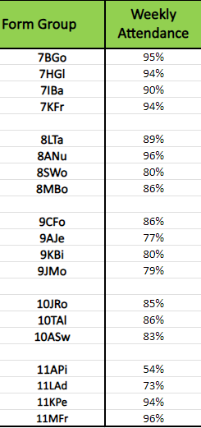

**Week Beginning 7th October 2024**

**In our post-pandemic era, your child’s attendance at school has never been more important. Research shows clearly that children with below 96% attendance are likely to get at least a grade less in their GCSE exams than they would with attendance of 96% or above. With less than 90% attendance, students are classed as persistently absent and are highly likely to get at least two grades lower in their GCSE exams. Help us to help your child be the best they can be – get them to school!**

**If your child is struggling to attend school, please do get in touch. We’ll do all we can to help.**

**Key Contacts for school**

|  |  |  |
| --- | --- | --- |
|  | **First point of contact** | **Email** |
| **Families in Year 7** | **Mr Oakley** | [**j.oakley@fi.coastandvale.academy**](mailto:j.oakley@fi.coastandvale.academy) |
| **Families in year 8** | **Mr Oakley** | [**j.oakley@fi.coastandvale.academy**](mailto:j.oakley@fi.coastandvale.academy) |
| **Families in Year 9** | **Mr Knowles** | **s.knowles@fi.coastandvale.academy** |
| **Families in Year 10** | **Mr Knowles** | [**s.knowles@fi.coastandvale.academy**](mailto:s.knowles@fi.coastandvale.academy) |
| **Families in Year 11** | **Mr Emmerson** | [j**o.emmerson@fi.coastandvale.academy**](mailto:jo.emmerson@fi.coastandvale.academy) |
| **Attendance** | **Mrs Herring** | [**m.herring@fi.coastandvale.academy**](mailto:m.herring@fi.coastandvale.academy) |
| **Reception and general enquiries** | **Mrs Bestington**  **Mrs Arnell**  **Mrs Walker** | [**admin@fi.coastandvale.academy**](mailto:admin@fi.coastandvale.academy) |

