AQA – A Level Physics

Foundations of A Level Physics  
  
Transition Work

Name:

**Flash cards – The following tables are information you are expected to know for A Level Physics, the questions and answers are below to help you construct flash cards, or use the QR code to get digital versions on Quizlet**

**Prefixes**



|  |  |
| --- | --- |
| What is the value of the prefix T (tera) | 10¹² |
| What is the value of the prefix G (giga) | 10⁹ |
| What is the value of the prefix M (mega) | 10⁶ |
| What is the value of the prefix k (kilo) | 10³ |
| What is the value of the prefix d (deci) | 10⁻¹ |
| What is the value of the prefix c (centi) | 10⁻² |
| What is the value of the prefix m (milli) | 10⁻³ |
| What is the value of the prefix μ (micro) | 10⁻⁶ |
| What is the value of the prefix n (nano) | 10⁻⁹ |
| What is the value of the prefix p (pico) | 10⁻¹² |

**Quantities, Units and Conversions**



|  |  |
| --- | --- |
| What six base units of the SI system are used in A Level Physics? | metre, kilogram, second, Ampere, Kelvin, Mole |
| What six base quantities of the SI system are used in A Level Physics? | length, mass, time, electric current, absolute temperature, amount of substance. |
| What is the base unit of mass? | kg |
| What is the base unit of length? | m |
| What is the base unit of time? | s |
| What is the base unit of current? | A |
| What is the base unit of temperature? | K |
| What is the SI unit of potential difference? | V |
| What are the SI units of density? | kgm⁻³ |
| What is the SI unit of energy? | J |
| What is the SI unit of power? | W |
| What is the SI unit of charge? | C |
| What is 1m² in mm²? | 10⁶mm² |
| What is 1m³ in cm³? | 10⁶cm³ |
| What is 1km² in m²? | 10⁶m² |
| What is 1cm³ in mm³? | 10³mm³ |
| There are 10²⁴ free charge carriers per m³ of a material. How many are there per mm³? | 10¹⁵ |
| 10⁶ particles strike each mm² of a surface per second. How many strike 1m² of the surface per second? | 10¹² |
| If there is 1 particle per mm³, how many are there per m³? | 10⁹ |
| Water has a density of 1000kgm⁻³. What is this in kgcm⁻³? | 10⁻³ |
| Water has a density of 1000kgm⁻³. What is this in gcm⁻³? | 1 |
| What six base units of the SI system are used in A Level Physics? | metre, kilogram, second, Ampere, Kelvin, Mole |

**Measurements, errors and uncertainties**



|  |  |
| --- | --- |
| What is a control variable? | Something that must be kept constant to prevent it affecting the dependent variable |
| What is meant by the repeatability of results? | Similar results would be obtained from repeats of the same measurement from the same experimental set up. |
| What is meant by the reproducibility of results | Similar results would be obtained from repeats by different people with different equipment. |
| How can you ensure a metre rule is held vertically? | Use a plumb line, set square or spirit level |
| How do you avoid parallax error? | Ensure eye, object and scale are all in line with each other OR ensure object and scale are directly adjacent to each other |
| What is meant by the term random error? | Errors that cause the measurement to vary in unpredictable ways. |
| What is a systematic error? | An error that causes the measurements to differ from the true value by a consistent amount. |
| What is a zero error? | An error that occurs due to the measuring instrument reading a non-zero reading when the measured quantity is zero. |
| What is meant by the accuracy of a result? | How close a measurement is to the 'true' or accepted value |
| What is meant by the precision of results? | How close repeated measurements are to each other. |
| What is meant by the resolution of a measuring instrument? | The smallest change in quantity that can be measured. |
| What determines the resolution when using a multimeter? | The scale selected. |
| What is the resolution of a metre rule? | 1mm |
| What is the resolution of vernier calipers? | 0.1mm |
| What is the resolution of a micrometer | 0.01mm |
| How do you find the absolute uncertainty from repeated readings? | ± ½ the range of the repeats |
| How do you estimate uncertainty when repeated results are identical? | ± ½ the resolution of the instrument |
| How do you calculate percentage uncertainty? | (Absolute uncertainty ÷ 'calculated OR measured' value) × 100 |
| What do you do to the uncertainties when quantities are added or subtracted? | The absolute uncertainties are added together |
| What do you do to the uncertainties when quantities are multiplied or divided? | The percentage uncertainties are added together |
| What do you do to the uncertainties when a quantity is raised to a power? | The percentage uncertainty is multiplied by that power |
| How do you find the uncertainty in a gradient? | ± (gradient of the line of best fit − gradient of the line of worst fit) |
| What is a line of worst fit? | The steepest or shallowest line that passes through the error bars. |
| What are error bars? | Lines to show the range of the absolute uncertainty of each data point on a graph |

**Key ideas:**

A – Converting areas and volumes can be tricky and often leads to mistakes by students.

If you are converting cm into m you divide by 100, if you convert cm2 into m2 you divide by 1002, If you are doing cm3 into m3 you divide by 1003

B – Physics studies objects ranging in size from sub-atomic particles to whole galaxies and the entire Universe. Using internet research or the Scale of the Universe website, <https://scaleofuniverse.com/en-gbm>, list two objects that are in the following size ranges:

**1pm – 1nm**

1. 2.

**1nm – 1μm**

1. 2.

**1μm – 1mm**

1. 2.

**1mm – 1m**

1. 2.

**1m – 1km**

1. 2.

**1km – 1Mm**

1. 2.

**1Mm – 1Gm**

1. 2.

**1Gm – 1Tm**

1. 2.

**1Tm – 1Pm**

1. 2.

**Exercises**

**1. Orders of magnitude and estimation**

1. How many iPhones would you need to stack on top of each other in order to reach the moon?
2. How long would it take you to walk to New York from here in seconds?

1. How many words are there in your physics text book?

1. What is the total mass in kg of the human population of the earth?

1. How many water molecules are there in a typical glass of water?
2. How long in seconds would it take to drive to the nearest star in a standard family car?

**2. Powers of 10**

Calculate the following using the EXP or x10x button on your calculator.

**3. Prefixes**

|  |  |  |  |
| --- | --- | --- | --- |
| **Prefix** | **Symbol** | **Name** | **Multiplier** |
| femto | f | quadrillionth | 10-15 |
| pico | p | trillionth | 10-12 |
| nano | n | billionth | 10-9 |
| micro | µ | millionth | 10-6 |
| milli | m | thousandth | 10-3 |
| centi | c | hundredth | 10-2 |
| deci | d | tenth | 10-1 |
| deka | da | ten | 101 |
| hecto | h | hundred | 102 |
| kilo | k | thousand | 103 |
| mega | M | million | 106 |
| giga | G | billion | 109 |
| tera | T | trillion | 1012 |
| peta | P | quadrillion | 1015 |

When you are given a variable with a prefix you should convert it into its numerical equivalent before you use it in an equation.

Always start by replacing the prefix symbol with its equivalent multiplier.

For example: 0.16 μA = 0.16 x 10-6 A

10 ns = 10 x 10-9 s

Replace the prefix with the equivalent multiplier:

e.g. 12.0 mm = 12.0**x10-3** m = 1.2x10-2 m

1. 1.4 kW =
2. 10 μC =
3. 24 cm =
4. 340 MW =
5. 46 pF =
6. 0.03 mA =

Express these with an appropriate prefix (Use the ENG button on your calculator where appropriate:

e.g. 5.6x10-11m = 56x10-12m = 56pm

1. 6.4x10-3 W =
2. 82.3x108 m =
3. 2.0x10-5 m =
4. 5.12x108 bytes =
5. 1000x10-9 A =
6. 0.520x104 Ω =

Change the prefix to the one required using the ENG and SHIFT+ENG buttons on your calculator:

1. 0.0063 kA = mA
2. 300 Mms-1 = Gms-1
3. 6x103 km = Mm
4. 0.0023 THz = MHz
5. 657,000 μm = cm
6. 2,112,000μs = ms
7. 0.0083GBytes = kBytes

**4. Conversions**

Remember to raise the conversion factor to the same power as the units.

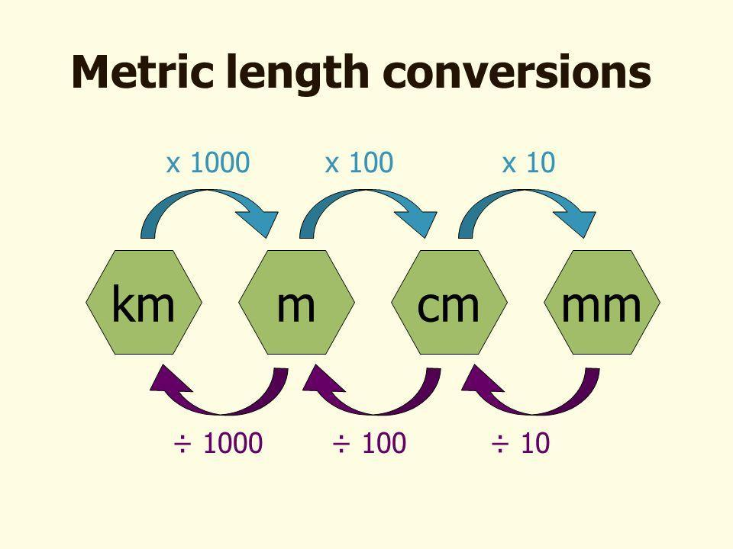

1. 1000cm2 = m2
2. 5mm2 = m2
3. 5550mm2 = m2
4. 15cm3 = m3
5. 7000cm3 = m3
6. 11mm3 = m3
7. 6x10-4 0Cs-1 = 0C per day
8. 1000kgm-3 = kgcm-3
9. 2x1024per m3 = per mm3
10. 2kg per min. = gs-1

**5. Rearranging Equations**

|  |  |  |  |  |  |
| --- | --- | --- | --- | --- | --- |
| Formula | Rearrangements | | | | |
|  |  | | |  | |
|  |  | | |  | |
|  |  | | |  | |
|  |  | | |  | |
|  |  |  | | |  |
|  |  |  | | |  |
|  |  | | | | |
|  |  |  | | |  |
|  |  |  | | |  |
|  |  | |  | | |
|  |  |  | | |  |

**6. Base and Derived Units**

The following quantities have the following base units:

s, L & r = m, v = ms-1, u = ms-1, a & g = ms-2, t & T = s, m & M = kg, V = m3



Identify whether the following equations are homogenous (do they all cancel out to equal the same thing) with respect to units:

1. v = u + at2

2. v2 = u2 + 2as

3. s = ut + ½ at

4. 2s = (v2 + u2)t2



5.

6.

Express the following quantities in terms of their base units:

7. Force, F in Newtons(N), given that F = ma

8. Work done, W in Joules(J), given that

9. Power, P in Watts(W), given that

10. Momentum, p, given that

11. Density, ρ, given that

12. Angular frequency, ω, given that

13. The gravitational constant G, given that

**7. Uncertainties**

If a single measurement is carefully and accurately taken the absolute uncertainty is taken as the smallest scale division on the instrument e.g. when using a ruler, then the absolute uncertainty will be ±(the resolution of the instrument), typically ±1mm.

1. Write down these measurements with their absolute uncertainty.
   1. 6.0 cm length measured with a ruler marked in mm

* 1. 0.642 mm diameter measured with a digital micrometer

* 1. A change in temperature of 36.9 °C temperature measured with a thermometer.

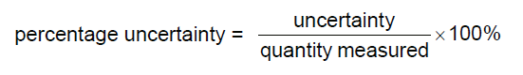

1. Calculate the percentage uncertainty in these measurements.
   1. 5.7 ± 0.1 cm

* 1. 2.0 ± 0.1 A

* 1. 450 ± 2 kg

* 1. 10.60 ± 0.05 s

* 1. 47.5 ± 0.5 mV

* 1. 366 000 ± 1000 J

1. Calculate the absolute uncertainty in these measurements.
   1. 1200 W ± 10%

* 1. 34.1 m ± 1%

* 1. 330 000 Ω ± 0.5%

* 1. 0.008 00 m ± 1%

|  |  |
| --- | --- |
| **Operation** | **Uncertainty** |
| Multiplication by a constant | % uncertainties are unaffected, absolute uncertainties are multiplied by the constant. |
| + OR - | Absolute uncertainties are added |
| x OR ÷ | % uncertainties are added |
| Quantity raised to a power (including fractional powers e.g. square roots) | Multiply the % uncertainty by the power. |

4. Calculate the absolute and percentage uncertainty in the total mass of suitcases of masses *x*, *y*, and *z*.

*x* = 23.3 (± 0.1) kg, *y* = 18 (± 1) kg, *z* = 14.7 (± 0.5) kg

5. Calculate the uncertainty in the resistance (R) of a bulb. The Equation is **R=V/I** and the following measurements were taken:

Potential Difference (V) = **1.1** V

Current (I) = **0.4** A

6. Calculate the uncertainty in the velocity (v) of a football. The equation is **v = s/t** and the following measurements were taken:

Displacement (s) = **26.5 ± 0.5** m

Time (t) = **0.6** s

7. A piece of string 1.000 (± 0.002) m is cut from a ball of string of length 100.000 (± 0.002) m. Calculate the length of the remaining string and the absolute uncertainty in this length.

8. A runner completes 100 (± 0.02) m in 18.6 (± 0.2) s. Calculate his average speed and the absolute uncertainty in this value.

9 Calculate the uncertainty in the power output (P) of a motor. The Equation is **P=W/t** and the following measurements were taken:

Energy delivered (W) = **24** J

Time (t) = **0.25** s

10. Calculate the uncertainty in total resistance. The equation is Rtotal = R1 + R2 and the resistors had the following values:

R1 = **100** **± 5 Ω**

R2 = **330** **± 10Ω**

11. A car accelerates, with constant acceleration, from 24 (± 1) m s–1 to 31(± 2) m s–1 in 9.5 (± 0.1) s. Calculate the acceleration. State your answer with its absolute uncertainty.

12A cube has a mass of 7.870 (± 0.001) kg and sides of length 10.0 (± 0.1) cm. Give the value of the density of the cube with its absolute uncertainty.

13. Calculate the percentage uncertainty in the Volume of a beach ball. The Equation is **4/3 π r3** and the following measurements were taken:

Radius of the beach ball (r) = **31** cm

14. Calculate the uncertainty in specific heat capacity. The equation is and the following measurements were made:

Heat energy supplied = 1.8kJ

Mass of object (m) = 0.052g

Starting temperature (T1) = 20 0C

Final temperature (T2) = 66 0C

15. Calculate the uncertainty in the resistivity of a cylindrical wire. The Equations are **R = V/I** and **ρ = RA/L, where A is the cross sectional area in m2** and the following measurements were taken:

Potential Difference = **1.1** V

Current (I) = **0.4** A

Diameter (A) = **0.24** mm

Length (L) = **1.200** m

16. Calculate the uncertainty in the Young Modulus of a metal wire. The equation is:

**Young modulus = FL/xA** the following measurements were taken:

Diameter of wire (d) = **0.18** mm

Tension in wire (F) = **10.8** N

Extension of wire (x) = **6** mm

Length of wire (L) = **1.100** m

**9. Graph Skills**

1. Using a transparent ruler draw a line of best fit on each of these graphs.

2. Complete the table

|  |  |  |  |  |
| --- | --- | --- | --- | --- |
| **Equation** | **Graph** | **Rearranged Equation** | **Gradient** | **Intercept** |
|  | y plotted on the y axis |  | *m* | *c* |
| x plotted on the x axis |
|  | y axis = *V* |  | *R* | 0 |
| x axis = *I* |
|  | y axis = *t* |  |  |  |
| x axis = *Q* |
|  | y axis = *l* |  |  |  |
| x axis = *R* |
|  | y axis = *V* |  |  |  |
| x axis = *I* |
|  | y axis = *E/t* |  |  |  |
| x axis = *V* |
|  | y axis = *EK* |  |  |  |
| x axis = *f* |
|  | y axis = 1*/v* |  |  |  |
| x axis = *m* |
|  | y axis = *mg* |  |  |  |
| x axis = *EP* |
|  | y axis = *e* |  |  |  |
| x axis = 1*/F* |
|  | y axis = 1*/λ* |  |  |  |
| x axis = *f* |
|  | y axis = *a* |  |  |  |
| x axis = 1*/t* |
|  | y axis = *v2* |  |  |  |
| x axis = *s* |
|  | y axis = *v* |  |  |  |
| x axis = *s* |
|  | y axis = *λ* |  |  |  |
| x axis = *w* |