**Transition Project Based Assignment: Health and Social Care**

**BTEC Level 3 Health and social care**

**As we lose ourselves in the service of others, we discover our own lives and our own happiness.**

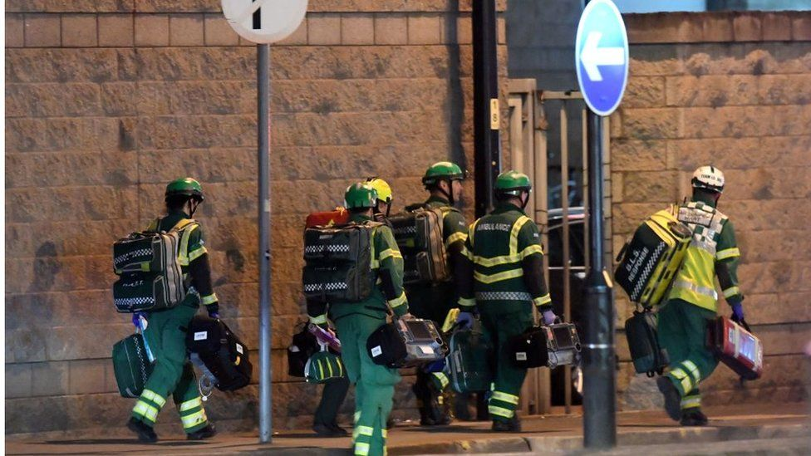

**Welcome to health and social care. The subject itself allows for a journey into the value of services that are integral to society. It will equip you with the skills, qualities and insight needed to become a better person. One who can actively make a difference and contribute in a very positive way.**

**The tasks given with allow you to formulate a foundation of knowledge and awareness needed to be successful at level 3 study.**

**I am available via email** [c.dawson@ll.coastandvale.academy](mailto:c.dawson@ll.coastandvale.academy) **if you have any questions and/or need support.**

**I look forward to seeing you in September.**

**Mr Dawson**

|  |  |  |  |  |  |
| --- | --- | --- | --- | --- | --- |
|  | **Completion date:**  **Sept 2023** | | | **Total hours to complete: 5 hrs** | **Grade range: A-E** |
|  | | | | | |
| **Learning objective:** | | To develop an understanding of BTEC Level 3 Health and Social Care | | | |
| **Planned learning outcomes:** | | By the end of the project you will have learned key terminology and a greater knowledge of aspects of this two year course. | | | |
| **Guidance:** | | This project is an introduction into the BTEC Level 3 Health and Social Care course. The project is made up of 3 tasks..  **Task 1:** students are asked to find the definition of keywords.  **Task 2:** Watch some of the recommended programmes/documentaries and read a book related to HSC and complete part of your learning log  **Task 3:** Using the knowledge you have gained from task 2 answer this essay question ‘Discuss the way Health and Social Care is portrayed within the media’  YOU WILL NEED TO HAVE THIS READY TO HAND IN THE FIRST LESSON IN SEPTEMBER! | | | |
| **TASK 1:** | | **Keywords** *(find the definitions of the following keywords)* | | | |
| **Keywords:** | | You will be asked to keep a glossary of keywords. Find the definition and use these keywords in your answers. | | | |
| Adolescence | | An important status change following the onset of puberty during which a young person develops from a child into a adult. | | | |
| Development | |  | | | |
| Fine motor skills | |  | | | |
| Growth | |  | | | |
| Milestone | |  | | | |
| Discrimination | |  | | | |
| Diversity | |  | | | |
| **TASK 2:** | | **Recommended programmes relating to Health and Social Care** | | | |
|  | | | | | |
| **TASK 3 :** | | | **Health and Social Care in the Media** | | |
| It is important to make the public realise about the issues in society that relate to health and social care. One way in which public awareness is raised about health and social care in general and issues that exist within the health and social care sector is through the media.  Your task is to pick…  ➢ x1 Film  ➢ x1 Book  ➢ x1 Documentary  You will then be asked to write an essay with the following title: ‘Discuss the way Health and Social Care is portrayed within the media’  You must watch/read the some of the examples on the previous slides you have picked and create notes to help with your essay. Consider the following:  • What issues, if any, are being raised in the information you have watched/read?  • How does the programme/book/article present H&SC?  Is the programme/book/article informative/helpful and why?  • Are there any quotes/scenes etc that stand out to you and why?  • How effective is the programme/book/article in raising public awareness about H&SC/Issues?  This list is NOT exhaustive there may be other questions /ideas you wish to consider as you watch or read  Documentary suggestions | | | | | |
|  | | |  | | |

Links for support:

<https://www.youtube.com/watch?v=kA5o1F50BpI>

<https://www.amazon.co.uk/BTEC-National-Health-Social-Student/dp/1292126019/ref=asc_df_1292126019/?tag=googshopuk-21&linkCode=df0&hvadid=310778801271&hvpos=&hvnetw=g&hvrand=15982073683465468227&hvpone=&hvptwo=&hvqmt=&hvdev=c&hvdvcmdl=&hvlocint=&hvlocphy=1006910&hvtargid=pla-562979290259&psc=1&th=1&psc=1>

<https://www.cypnow.co.uk/features/article/social-workers-on-the-small-screen>

<https://www.communitycare.co.uk/2017/10/09/irresponsible-inaccurate-social-workers-react-eastenders-child-removal-storyline/>

**What will I be studying in Health and Social Care?**

This course allows you an insight in the many roles available within health and social care from nurses to social workers to child care assistants and beyond they have many key features that we shall explore and apply. In year 12 you will study Unit 2 and Unit 14. You will be expected to sit an external Unit 2 exam in Jan 2025 and submit your Unit 14 assignment in May 2025.

These units which will help you to gain skills that will be valuable in your chosen profession or future study. You learn about the human body and mind alongside the changes across time. You also learn what it means to work in the sector and what skills and behaviours you will need to develop.

During unit 2, **Working in health and social care,** you focus on:

* How you will be assessed: this is a paper based exam which lasts for 1 hour 30 minutes which is worth 90 marks. There is a variety of short- and long- answers. The questions are designed to test your knowledge on all areas of the sector and legislation and policy underpinning these.

During unit 14, **Physiological disorder,** you focus on:

* How you will assessed: by a series of coursework assignments set at school. You will need to check that your work first meets all the pass criteria before moving on to merit and then finally distinction criteria.