**A-Level Psychology**

“Some people are afraid of what they might find if they try to analyse themselves too much, but you have to crawl into your wounds to discover where your fears are. Once the bleeding starts, the cleansing can begin.”



  

[](http://www.google.co.uk/imgres?imgurl=http://fractal.fractalenlighten.netdna-cdn.com/wp-content/uploads/2013/12/transpersonal_psychology.jpg&imgrefurl=http://fractalenlightenment.com/16555/spirituality/psychology-with-a-soul-views-of-a-transpersonal-psychologist&h=413&w=625&tbnid=7Vbwb4jOpDYwwM:&zoom=1&docid=lSKVFqwQKo6HqM&ei=KWuJVaSuC4PV7gbymonYCA&tbm=isch&ved=0CGoQMyhAMEA)

Mr Dawson

Welcome to Psychology!

You have chosen to study A-level psychology at Lady Lumley’s Sixth Form.

You will be studying AQA A level Psychology. For year 1 you will study seven different topic areas:

* Paper 1:
  + Social influence
  + Memory
  + Attachment
  + Psychopathology
* Paper 2:
  + Approaches
  + Biopsychology
  + Research methods

In September we will be starting with the memory topic to include research methods followed by attachment and psychopathology. Unless otherwise told, these are the topic areas you will be assessed on for the trial exam in January.

As psychology is a new subject for most students it is important that all students have a clear understanding about the nature of psychology and what is required for the course.

Psychology is a subject that requires skills from all of the core subjects: English, mathematics and science. Students are required to write coherent and well planned essays; interpret data and conduct mathematical tests; to know and understand some basic anatomy. Please acknowledge that psychology is a very difficult, academic subject that will ask a lot of you. 50% of all the work needed will take place outside of lessons so prepare for independence. This is not a filler subject; it requires full commitment, passion and endurance.

Within this pack I have included a range of tasks for you to complete in order to prepare you for September. If, at any point, you are struggling and need support please feel free to contact me, [C.dawson@ll.coastandvale.academy](mailto:C.dawson@ll.coastandvale.academy)

It is imperative that these tasks are completed ready for our first lesson together.

I look forward to seeing you in September.

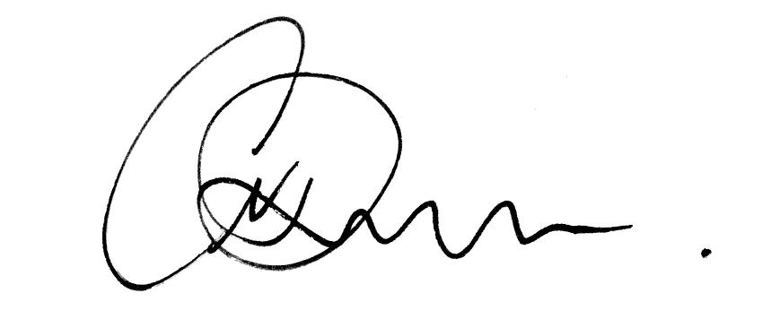

Mr C Dawson (Psychology department)

**Tasks:**

**Task 1: Your personality.**

[**https://www.16personalities.com/**](https://www.16personalities.com/)

**Take the test and summarise your results on 1 page of A4 with a photo of yourself on the sheet and your name. For example, I am a “Mediator” which suggests that I am an introvert and gain energy from time on my own. I am a dreamer.**

**Do you agree with the results? Are the results accurate of you?**

**What can the results tell me about you?**

**\*Write a brief overview of your results stating what personality type you are, what it represents and how others can work with you based on your results.**

**Task 2: Psychological Approaches**

Approaches are specific areas of psychology that attempt to explain behaviour. They include theories and specific psychologists who investigate the mind and behaviour from their associated approaches.

1. **Note down the key points of each approach in each box.**
2. **What image could you use to represent each of the approaches? Include this in each box.**
3. **Identify one word or statement that can summarise each approach.**
4. **Identify the key differences between each approach.**

Biological approach Cognitive approach

**Learning: Learning- Social**

**Behavioural approach learning theory**

**Task 3: Individual Research.**

As psychology is a new subject it is important that you understand what the subject is.

* What is psychology?
* What do psychologists do and what can they offer us?
* Name one famous psychologist and explain why they are famous.
* What jobs can psychology lead you to?
* Why do you want to study psychology?

This is a useful place to start:

<http://www.bbc.co.uk/science/humanbody/mind/articles/psychology/what_is_psychology.shtml>

**Task 4:**

We will be starting ***memory*** in September and one of the biggest challenges will be learning, understanding, applying, evaluating and recalling key psychology theories and research in detail.

1. Please research and give definitions of:

*Coding

*Duration

*Capacity

*Short-term memory

*Long-term memory

1. Please research the ***multi-store model of memory*** and label/annotate the diagram below to include coding, capacity and duration for short-term memory (STM) and long-term memory (LTM).

LTM

STM

SR

1. **How does information get from the sensory register (SR) to the STM? How does information transfer from the STM to the LTM?**

**Links for memory:**

<https://www.youtube.com/watch?v=yw3CFPHFJTk>

<https://www.youtube.com/watch?v=5onrRIfT3M8>

A level revision website for research

<https://www.simplypsychology.org/a-level-psychology.html>

<https://www.s-cool.co.uk/a-level/psychology/social-influence>

<https://revisionworld.com/a2-level-level-revision/psychology/useful-links-3>

<https://studywise.co.uk/a-level-revision/psychology/notes/#2>

**Film/TV**

Films that would be beneficial watching prior to the course starting in September:

*The experiment (starring Adrien Brody)

*The wave (german with subtitles)

*The Stanford prison experiment (starring Ezra Miller)

*The Bourne identity- series

TV- Any documentaries on TV or via youtube that have a focus on the mind and behaviour will help you prepare for the course.

TED talks on youtube are also very informative:

Speakers that would benefit include:

*\*Susan Cain (personality)*

*\*Elizabeth Loftus (eyewitness testimony)*

*\*Philip Zimbardo (Lucifer effect- good people doing bad things)*

*\*Angela Lee Duckworth (mindset)*

Thank you

[C.dawson@ll.coastandvale.academy](mailto:C.dawson@ll.coastandvale.academy)