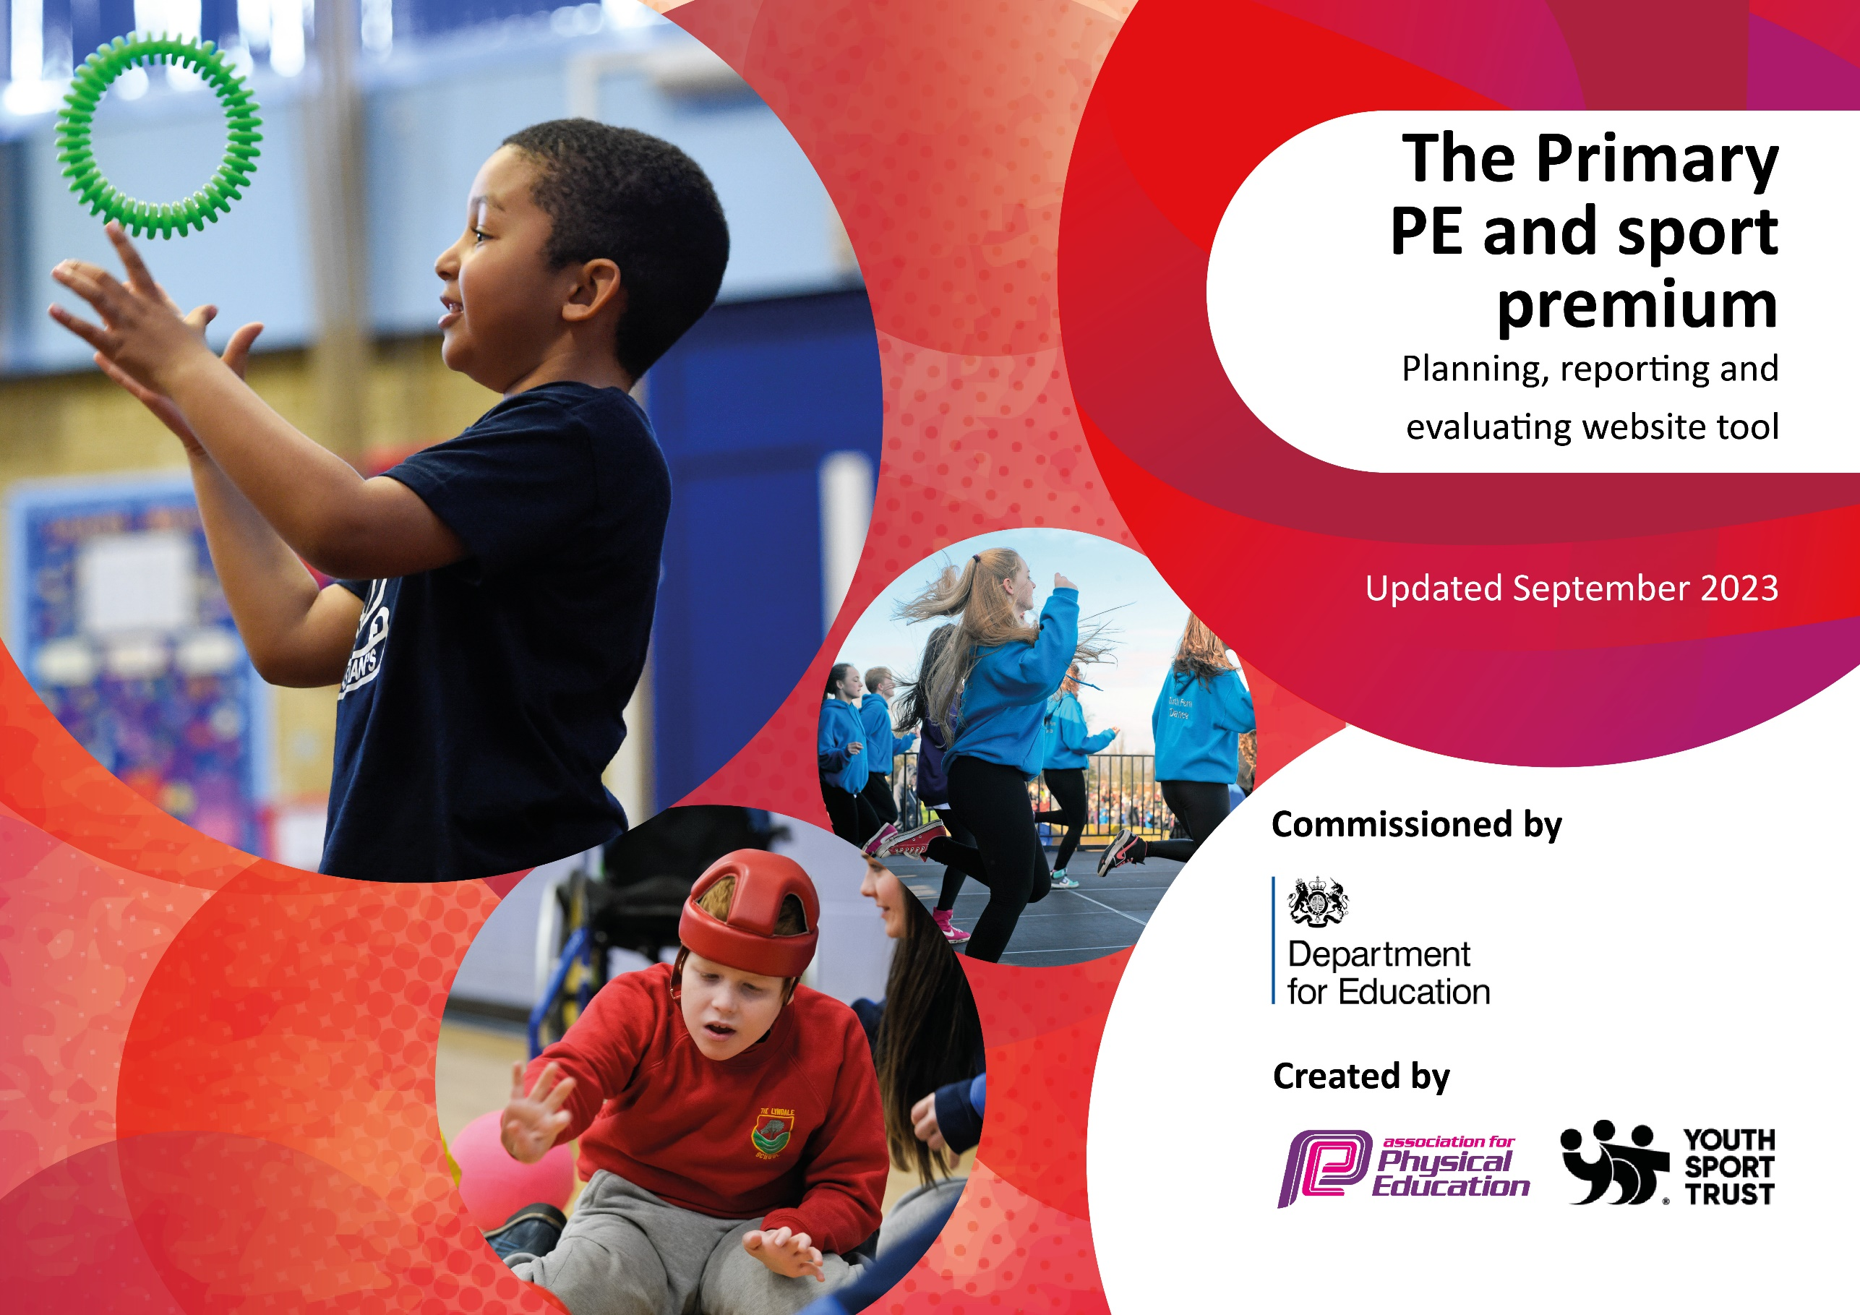

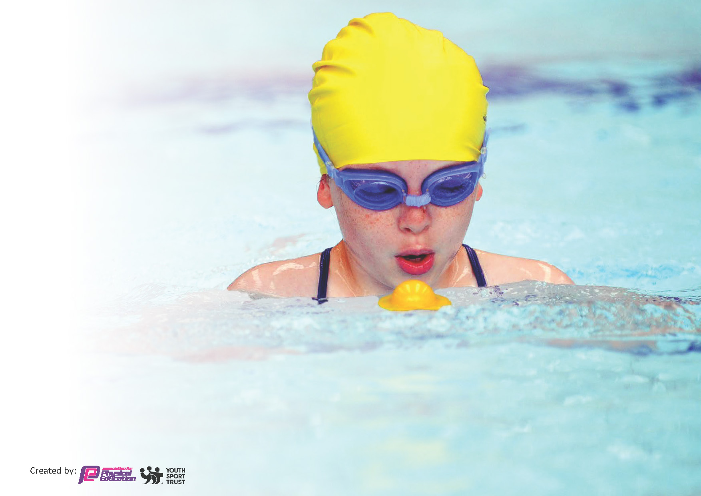
This template can be used for multiple purposes:
by:
- It enables schools to effectively plan their use of the Primary PE and sport premium
- It helps schools to meet the requirements (as set out in guidance) to publish information on their Primary PE and sport premium
- It will be an effective document to support Ofsted inspections enabling schools to evidence progress in Physical Education (PE) and evidence swimming attainment, which forms part of the PE National Curriculum. We would recommend schools consider
the Intent, Implementation and Impact of any spend, as examined within the Education Inspection Framework.

It is important that your grant is used effectively and based on school need.

Schools must use the funding to make additional and sustainable
improvements to the quality of the PE, School Sport and Physical Activity (PESSPA)
they offer. This means that you should use the Primary PE and sport premium to:

- Build capacity and capability within the school to ensure that improvements made now will benefit pupils joining the school in future years
- Develop or add to the PESSPA activities that your school already offers.

The Primary PE and sport premium should not be used to fund capital spend projects; the school’s core budget should fund these. Further detail on capital expenditure can be found in the updated Primary PE and sport premium guidance.

The Primary PE and sport premium guidance, outlines 5 key priorities that funding should be used towards. It is not
necessary that spending has to meet all the key priorities, you should select the priorities that you aim to use any funding towards.

Although completing this template is not a requirement for schools, schools are required to publish details of how they spend this funding. Schools must also outline what the impact this funding has had on pupils’ PE and sport participation and attainment and how any spending will be sustainable in the future. All funding must be spent by 31st July 2024.

The Department for Education has worked closely with the Association for Physical Education (afPE) and the Youth Sport Trust (YST) to develop this template and encourages schools to use it. This template is an effective way of meeting the reporting requirements of the Primary PE and sport premium.
Review of last year’s spend and key achievements (2023/2024)

We recommend you start by reflecting on the impact of current provision and reviewing your previous spend.

Activity/Action | Impact | Comments
Key indicator 1:  - Increased engagement of physical activity on the playground  - For pupils to volunteer and lead physical activities at playtimes and lunchtimes  - Resources available to engage in physical activity and skills  Key indicator 2:  - For pupils to be physically active throughout the school day.  - More pupils to engage in physical activities beyond the school day  Key indicator 3  - All staff are able to teach highly effective PE sessions.  Key indicator 4  - All pupils by the end of Y6 to achieve the expected standard in swimming.  - All year 4 children to experience outdoor adventure residential to East Barnby  Key indicator 5:  - To have a high level of participation in competition within school and with local schools across all sports intended to build children’s confidence, act as incentive for good behaviour in school, improve teamwork and sporting behaviour, improve skills and tactics in sports entered, build resilience, and help children become better learners | Trained playleaders support others in ensuring there is a wide range of physical activities on the playground at both playtime and lunchtime on both Key Stage 1&2.  Pupil voice supports the decision of activities and ensures there is a range of activities and engages more children.  Most children engaged in these activities.  Time on the Trim Trial not only supports balance and coordination but gives children the opportunity to re-energise and refocus.  46% of KS2 pupils engaged in additional after school activities.  Complete PE provides CPD for all staff delivering the PE curriculum to ensure we deliver a high-quality PE learning for all.  The scheme provides detailed lesson plans which can be adapted depending on class needs.  All staff can access the scheme.  Through high quality teaching of swimming, and extensive number of weeks year 5 attend the swimming pool – we have 86% of Year 6 pupils that can competently, confidently, and proficiently swim 25m.  All children were invited to attend the 3-day residential at East Barnby at a subsidized price. 71% of pupils attend.  Over the year, we have been involved in more competitive sports with other local schools.  This has involved Cricket, Netball, Football, Olympic events alongside Scarbrough College and Boccia.  This has improved children’s confidence and have supported the children in becoming better learners.  They have understood and improved teamwork skills. | DfE Behaviour Hub Lead School commented on the impact of the effective playleaders and engagement in physical activity.  Additional resources have supported the implementation.  Next Steps – To explore CPD on Brain Breaks to refocus on learning through Physical Activities  Using Pupil Voice and providing after-school clubs that they requested supported the increased number of pupils engaging in the clubs.  Next Steps – To increase the physical activities provided through after school clubs for KS1.  Complete PE to support the delivery of highly effective PE sessions during the next academic year.  Additional swimming teacher trained and qualified to add capacity to the swimming groups to deliver more bespoke targeted teaching.  The cost is significantly high for the outdoor adventure residential.  Next Steps – to place a booking at Dallow Gill (Delta Trusts residential venue)  Next Steps – To continue to build on the participation of sports across the town/

Key priorities and Planning 2024/25
This planning template will allow schools to accurately plan their spending.

Action – what are you planning to do  e.g. Introduce lunchtime sport sessions/activities for pupils. | Who does this action impact?  Lunchtime supervisors / teaching staff, coaches - as they need to lead the activity pupils – as they will take part. | Key indicator to meet | Impacts and how sustainability will be achieved?  More pupils meeting their daily physical activity goal, more pupils encouraged to take part in PE and Sport Activities. | Cost linked to the action  £1000 costs for additional coaches to support lunchtime sessions.
Increased engagement of physical activity on the playground.  Resources available to engage in physical activity and skills  More pupils to engage in physical activities beyond the school day  To provide top up swimming sessions for those pupils not achieving the expected standards after the core provision | Playleaders – leading the activities  MSAs/TAs – supervising the leaders  Pupils – engaging in the activities  Coaches – leading the activities  Staff – delivering sessions  Pupils | Key indicator 1:  The engagement of all pupils in regular physical activity | All playgrounds will have regular activities for pupils to engage with Playleaders will lead a variety of physical activities during lunchtime and playtime. Pupil voice supports the choice of activities available.  Additional physical resources to be purchased to enhance learning throughout the year. Resources for each year group to support physical activity and skills  More pupils actively involved in physical after school clubs delivered by both internal and external staff/coaches.  Use of social media is effective in signposting pupils to local physical activities & events beyond the school day  A greater % of pupils reaching the expected standard of swimming. (>83%) | £2000  £4000
Play leaders award for YR5/6 pupils, awards for skills of the week champion.  Pupils to be encouraged to walk, bike or scooter to school. | Playleaders  Pupils  Pupils | Key indicator 2:  The profile of PE and sport being raised across the school as a tool for whole school improvement | Children will be more motivated to take part in skill of the week led by playleaders with an award presented each week in assembly for the various age ranges.  Annual training for new playleaders during Summer Term  Bike/road safety talks will be delivered by local PCSOs  Storage now available for pupils to store their bike/scotter.
All staff are able to teach highly effective PE sessions. | Staff including support staff. | Key indicator 3:  Increased confidence, knowledge and skills of all staff in teaching PE and sport | High quality CPD has enabled staff to teach highly effective sessions with increased knowledge and skills of the subject.  All staff have access to a high-quality PE scheme with CPD training  A clear focus, teaching guide, learning materials ensure pupils receiving quality PE sessions | £1500  £300
Sports Week provides a broader experience of high-quality sports delivered by professional coaches.  Provide coaches to deliver after school clubs for a termly block.  Children in Year 4 to engage in the residential visit to DallowGill | Sports Coaches  Pupils (Nursery – Year 6)  Pupils  Coaches  Year 4 pupils | Key indicator 4:  Broader experience of a range of sports and activities offered to all pupils | Children experienced a range of activities and signposted to out of school provision.  To get further support the CPD for all staff through high quality coaches.  Pupil voice to determine the sports coaches requested from the pupils and measured against sign up and attendance  All children have increased confidence, knowledge, independence and experience of a wider range of physical activity. | £3000  £2000  £3000
To promote physical activities through social media. To give out flyers from local sports clubs and events in the local area.  To have a high level of participation in competition within school and with local schools across all sports intended to build children’s confidence, act as incentive for good behaviour in school, improve teamwork and sporting behaviour, improve skills and tactics in sports entered, build resilience and help children become better learners | All pupils and families  Pupils  Staff | Key indicator 5:  Increased participation in competitive sport | Social media is effective in promoting the physical activities that are within the local area for pupils to engage with beyond the school day.  School will enter into local organised sports competitions and continue to create links with local schools to provide opportunities beyond that of the local sports partnership to try and increase the numbers of children participating in sporting teams for the school.  Sports coaches to provide additional capacity for competitive sport in-house and interschool. | £1500

Key achievements 2024-2025
This template will be completed at the end of the academic year and will showcase the key achievements schools have made with their Primary PE and sport premium spending.

Activity/Action | Impact | Comments

Swimming Data
Meeting National Curriculum requirements for swimming and water safety.
Priority should always be given to ensuring that pupils can perform safe self-rescue even if they do not fully meet the first two requirements of the National Curriculum programme of study

Question | Stats: | Further context  Relative to local challenges
What percentage of your current Year 6 cohort can swim competently, confidently and proficiently over a distance of at least 25 metres? | 86% | At the start of the sessions, only 2 pupils confidently entered the water.  Many sessions began with overcoming water anxiety and encouraging children to enter the water.  Additional swimming teachers trained, enabling the groups to be smaller and more focused.
What percentage of your current Year 6 cohort can use a range of strokes effectively [for example, front crawl, backstroke, and breaststroke]? | 79% | When children have swam their 25m, only 79% of pupils effectively used a range of strokes. They are more effective using front stroke and backstroke.

What percentage of your current Year 6 cohort are able to perform safe self-rescue in different water-based situations? | 92% | 100% of pupils have been taught how to perform safe self-rescue through finding air and safety by turning onto their back and floating. This has been taught during swimming sessions at the pool, and additional water safety messages from local PSCOs and the local Everyone Active staff.  Only 92% of the pupils were able to perform the safe self-rescue in the pool due to water confidence.
If your schools swimming data is below national expectation, you can choose to use the Primary PE and sport premium to provide additional top-up sessions for those pupils that did not meet National Curriculum  requirements after the completion of core lessons. Have you done this? | Yes/No | Additional £1796.07 has supported additional swimming lessons to ensure there was a higher percentage of pupils able to swim 25m.
Have you provided CPD to improve the knowledge and confidence of staff to be able to teach swimming and water safety? | Yes/No | An additional member of staff completed the swimming qualification to add capacity to the swimming teaching team to ensure groups at the pool were small and focused.

Signed off by:

Head Teacher: | Cheryl Cappleman
Subject Leader or the individual responsible for the Primary PE and sport premium: | Alison Langley
Governor: | Tim James – Chair of Governors
Date: | 22/7/24

