Rudgate Diversification Project

Scenario: Craig Lee is a successful entrepreneur in North Yorkshire. He owns a company called Rudgate which is situated in Tockwith, York. In recent years, the business has gone from strength to strength, generating retained profit. In order to diversify the business, Craig would like to enter the restaurant market. He has identified the town of Pickering as a potential location to open up the new business. You have been hired as a business adviser to assist Rudgate. You will need to undertake significant market research and marketing analysis.

Task 1: Market Research – Samples
You will need to undertake significant market research upon the local restaurant industry in order to advise Rudgate correctly. In order to do this, you are required to investigate 3 different sampling methods. This are Random, Quota and Stratified.
You will need to evaluate your research and provide Rudgate with the sampling method that you will be implementing with Task 2.

Task 2: Market Research – Primary Research
You are required undertake market research to answer the following questions.
- Who are the main restaurants that currently operate in Pickering?
- What type of restaurant should Rudgate open in Pickering?
- Do Rudgate need to consider online retailing methods?
- What price would consumers be willing to spend on restaurants?
- Which location should the restaurant be situated in?
Advice
- Survey monkey and Microsoft Forms are both useful tools for creating questionnaires.
- When creating the survey, think of questions that can be easily analysed.
- Use a suitable sample size to ensure accurate results.
- You may need to estimate some of the data so that you can provide graphical evidence of your research.
Formula for Market Share
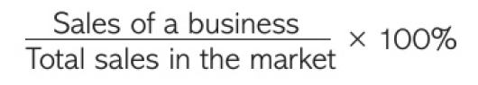
Example of graphical evidence of mobile phone industry
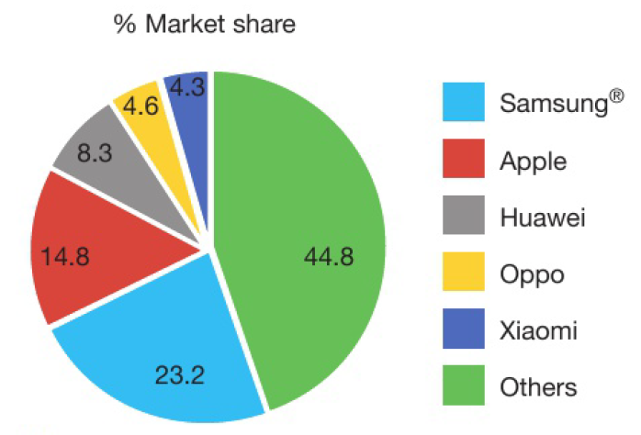

Task 3: Market Mapping
Market mapping is the process of using a graph to plot competitors and their products to understand competitor behaviour and spot a gap in the market. It also allows a business to see who their competition will be and what other products and services are available in the same sector. Undertake further research on what market mapping is. You are required to present a perceptual map for the restaurants in Pickering that you have included in your primary research tasks.

Example of a perceptual map for cars

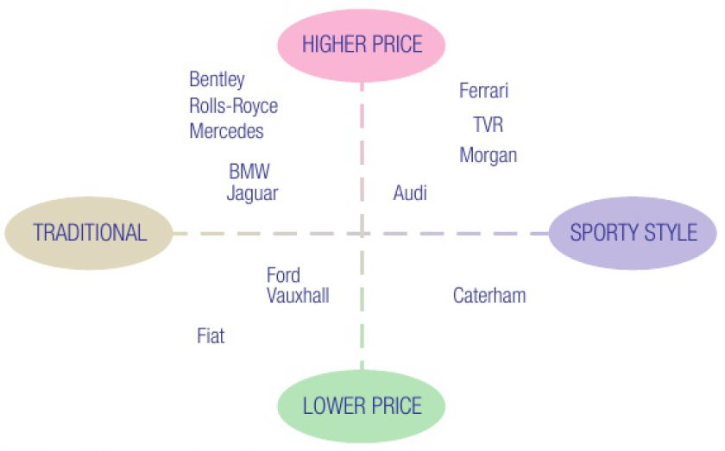

Advice
- This research should help you to identify a gap in the market so that you can advise Rudgate accordingly.

Task 4: The final presentation / report
Using your research from previous tasks, you are now required to put a report together that collates all research and findings, with recommendations to Rudgate. These should include the following;
- Task 1: Evidence of research into methods of samples with an evaluation outlining which sample method Rudgate will use.

- Task 2: Primary research finding upon restaurants in Pickering, consumer demand and location. Some indication of market share should be provided.

- Task 3: Perceptual map should be created with suggestion of market position of local restaurants with identification of possible gaps in the market for Rudgate

In addition, the final presentation / report should provide final recommendations for Rudgate on restaurant genre, location and possible pricing strategies.

Further Research Opportunities
Edexcel AS Level Student Business Studies Book (See Appendix)

Success Criteria Rubric
 | Task 1 | Task 2 | Task 3 | Task 4
PASS | Brief research and understanding provided for some methods of samples | Brief market research undertaken with results presented in a limited way | Perceptual map attempted which demonstrates awareness of competitors market position | Final presentation of work attempted with some recommendations provided.
MERIT | Sound research and understanding provided for 3 methods of samples | Sound market research undertaken, and results presented in an informative manner | Perceptual map demonstrates sound awareness of competitors market position | Final presentation of work presents majority of research undertaken and provides sound recommendations
DISTINCTION | Thorough research and understanding of 3 methods of samples | Thorough market research undertaken with results presented in a professional manner | Detailed perceptual map that clearly demonstrates awareness of competitors market position | Final presentation of work is professional and clearly demonstrates suitable recommendations

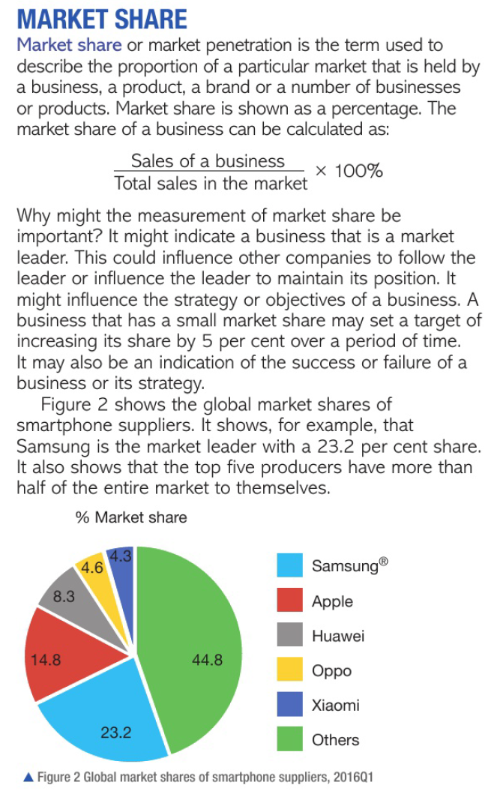
Appendix
